## Tajweed Rulings

The Tajweed Quran incorporates color-coded indications to facilitate proper recitation. Let’s delve into the colors and their roles:

|  |  |  |
| --- | --- | --- |
| **Rule/Icon** | **Description** | **Font Code** |
| A | **Normal Text** | A |
| B | **Alif Hamzat Wasl**  Hamzatul-wasl is read when the sentence or verse is started by it. It is represented by small ص  on top of it. If this Hamza comes in the middle of sentence or verse then it is silent or ignored and is not read. | B |
| C | **Idgham / Silent**  Represents letters that are **not pronounced**. For instance, the assimilated “L” in “اَلشَّمْس” (ash-shams) is never pronounced. Similarly, the Noon in “كَأَن لَّمْ” (ka’an lamma) is pronounced like “كَأَلَّمْ” (ka’allam). | C |
| D J E | **Indicates compulsory lengthening (Madd)**  When you encounter red letters, it signifies that you should elongate the pronunciation of the vowel. There are three variations: |  |
| D | **Madd Lazim 6 Harakah**  Necessary prolongation (six vowels), which is about half a second, as seen in “الْحَآجّ” (al-haajj). | D |
| J | **Madd Wajib 4-5 Harakah**  Obligatory prolongation (four or five vowels), such as in words like “أَوْلِيَآء” (awliyaa). | J |
| E | **Madd Arid Lis-sukoon 2-4 or 6 Harakah**  Permissible prolongation (two, four, or six vowels). | E |
| F | **Madd 2 Harakah** General Prolongation (two vowels). | F |
| G | **Ghunna**  Denotes **nasalization**. The sound comes from the nose and continues as long as two vowels. It includes:   * + **Disappearance (Ikhfa’a)**, as in “أَن تَخْشَوْه” (an takhshawhu).   + **Stresses (N or M)**, seen in words like “فَإِنَّهم” (fa innahum) or “مِمَّا” (mimma).   + **Inversion (Iglab)**, where the “N” is colored gray and inverted into a nasalized “M,” as in “مِن بَعْد” (min ba’d). | G |
| H | **Tafkhim**  Used for letters that require **emphatic pronunciation**. When you encounter dark blue letters, emphasize their sound. For example, “الحرام” (al-haraam). | H |
| I | **Qalqalah**  Indicates the sound of Qalqalah (a plosive sound). When pronounced, these letters appear to have an echoing quality. For instance, “لقد” (laqad). | I |
| L | **Waqf Mark with Shapes Outline** indicating diacritic to be silenced/not pronounced. | L |
| W | **Normal Ayah Icon with number** (e.g. 1:1) | W |
| Y | **Special Ayah Icon with number** indicating preferred continuation without stopping (e.g. 110:1) | Y |

Remember, these color codes aid in understanding and applying the rules of Tajweed while reciting the Quran.

For further exploration, you can refer to the [Tajweed Quran Color Roles](https://easyquran.com/en/tajweed-quran-colors-roles/) guide. May your recitation be blessed!

**Source:** <https://easyquran.com/en/tajweed-quran-colors-roles/>

Learn more about Tajweed : <https://quranhouse.online/tajweed/tajweed-rules/>

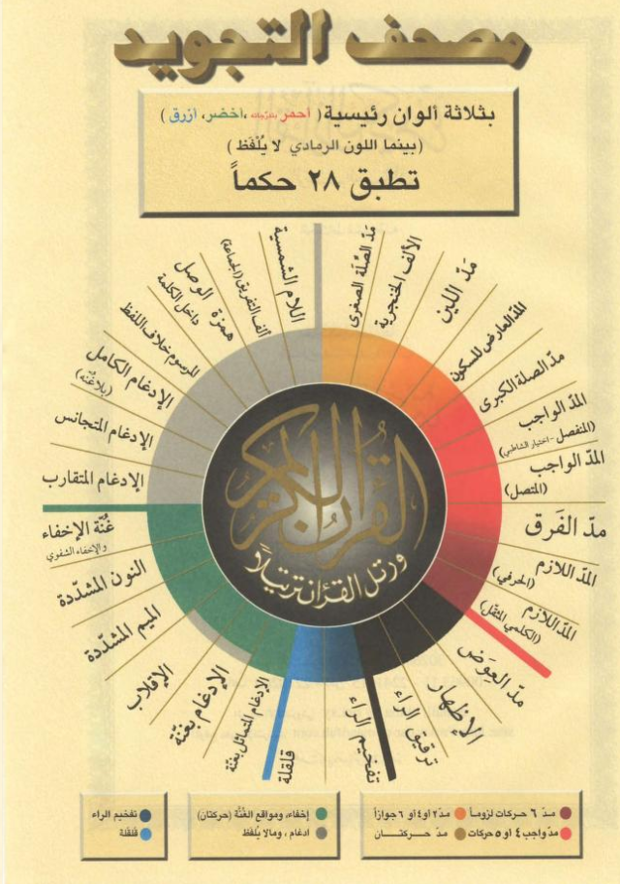

**(WIP) Advanced / Detailed Tajweed Rules**